By what you wrote, you are missing a critical piece of understanding: the difference between a class and an object. __init__ doesn't initialize a class, it initializes an instance of a class or an object. Each dog has colour, but dogs as a class don't. Each dog has four or fewer feet, but the class of dogs doesn't. The class is a concept of an object. When you see Fido and Spot, you recognise their similarity, their doghood. That's the class.
When you say
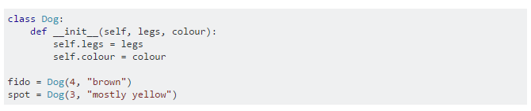

You're saying, Fido is a brown dog with 4 legs while Spot is a bit of a cripple and is mostly yellow. The __init__ function is called a constructor, or initializer, and is automatically called when you create a new instance of a class. Within that function, the newly created object is assigned to the parameter self. The notation self.legs is an attribute called legs of the object in the variable self. Attributes are kind of like variables, but they describe the state of an object, or particular actions (functions) available to the object.
However, notice that you don't set colour for the doghood itself - it's an abstract concept. There are attributes that make sense on classes. For instance, population_size is one such - it doesn't make sense to count the Fido because Fido is always one. It does make sense to count dogs. Let us say there're 200 million dogs in the world. It's the property of the Dog class. Fido has nothing to do with the number 200 million, nor does Spot. It's called a "class attribute", as opposed to "instance attributes" that are colour or legs above.
Now, to something less canine and more programming-related. As I write below, class to add things is not sensible - what is it a class of? Classes in Python make up of collections of different data, that behave similarly. Class of dogs consists of Fido and Spot and 199999999998 other animals similar to them, all of them peeing on lampposts. What does the class for adding things consist of? By what data inherent to them do they differ? And what actions do they share?
However, numbers... those are more interesting subjects. Say, Integers. There's a lot of them, a lot more than dogs. I know that Python already has integers, but let's play dumb and "implement" them again (by cheating and using Python's integers).
So, Integers are a class. They have some data (value), and some behaviours ("add me to this other number"). Let's show this:
